MS Word Training - Session 1: Part 1

Introduction to Word Formatting & Styles
Introduction

The Word Environment
To start up Word:
- Click the Start button, Programs and then Word.
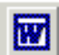
- Alternatively click on the Word icon on the Quick Launch portion of the taskbar at the bottom
of the screen:

The Word screen
On start up, Word automatically loads a document – Document1 as identified in the title bar. This is a temporary area in which you enter your text. Once you have entered some data you would not want to lose, you can save it as a file.

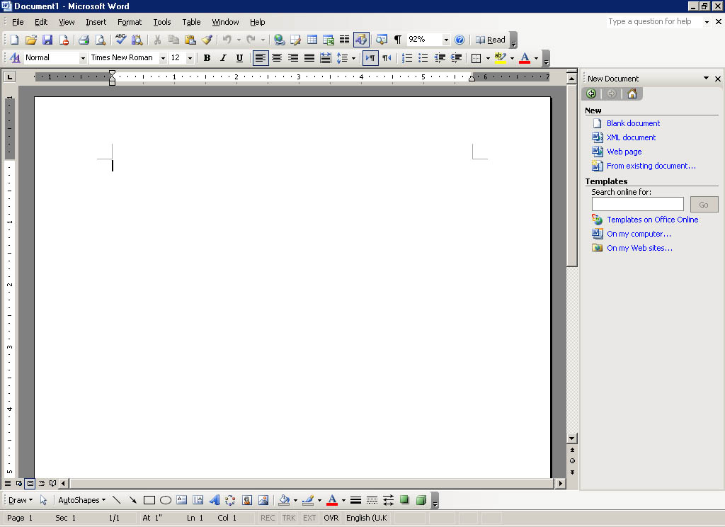
Menu bar
Title bar
Standard toolbar
Formating toolbar
Task pane
Insertion point
Horizontal ruler
Status bar
Scroll bars
View
buttons
Drawing
toolbar

Your screen should look the same as the one shown above, i.e. the Standard and Formatting toolbars, and the task pane are displayed. The ruler, status bar and the scroll bars are all visible. Take a moment to locate these now on your screen.

The task pane
Word 2002 and 2003, like the other Microsoft Office applications, has a new feature called the task pane (visible on the right-hand part of the screen). This feature is a Web-style command area which is an alternative to a dialog box, and allows you to carry out certain basic operations or choose selected options. It gives you one location for the actions you use most when doing your work, so you don’t have to use the menus.
Most Office applications contain the following task panes: New File/Workbook/Document (the name varies according to their application), Clipboard, Search and Insert ClipArt. Some of the task panes and features listed below will be covered in the Getting more from Word document.

Word task pane descriptions
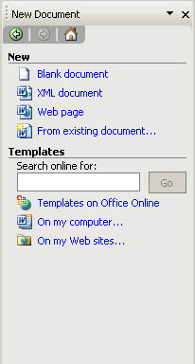
New Document – This task pane displays some of the commands used most commonly when creating a new document or using templates, for example, open and close.
Clipboard – The Clipboard task pane is used for copying and pasting multiple items into Word.
Search – This task pane allows you to look for your work (files, workbooks, Web pages, presentations, graphics etc.) in locations such as your R drive and hard disk drive.
Insert ClipArt – This task pane is used for inserting images into your Word document. It provides you with quick access to ClipArt through a search function that finds and displays clips for you by title, collection or type.
Styles and Formatting – This task pane allows you to apply styles to text or to change the appearance of your document.
Reveal Formatting – Use this task pane to view and modify the styles and formatting in your text.
Mail Merge – This task pane provides you with six easy steps through the process of producing a bulk mailing, either on paper or by e-mail.
Translate – The Translate task pane can do a machine translation of a word, phrase, or selection of text from one language into another (this is only available for certain languages).

Displaying the task pane
If the task pane is not visible on the right-hand side of your screen, you can display it as follows by selecting Task Pane from the View menu.

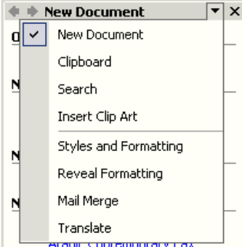
Changing the task pane
Arrows allow you to scroll through the different task panes.
Other Task Panes arrow.
- Click on the Other Task Panes arrow to display the options shown in the image opposite.
- Select the required option.
You can also use the arrows to go backwards and forwards to previously displayed task panes.

Accessing commands
Some of the commonly used commands in Word are accessed through the task pane, as described above. Menus, toolbars and keyboard shortcuts are other methods for accessing commands.

Menus
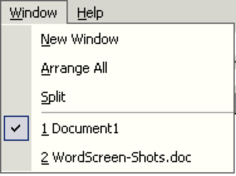
Commands may be accessed by choosing an option from the menu bar at the top of the Word screen. By clicking on an option, the user is often faced with a second selection from either a sub-menu or a dialog box before the command can be carried out.
All commands can be accessed through Word’s menu system. You can personalise your menus in Word, so that it displays all commands, or the most frequently used commands. To do this, go to Customize on the Tools menu and click the Options tab.

Using the mouse
Click on a menu item on the menu bar and click on the option you require in the menu.
or
Right-click to display the context-sensitive menu.

Using the keyboard
There are two keyboard methods for accessing menu commands; using the Alt key, or using the Ctrl key:
- Hold down the Alt key and press the letter underlined in the menu item you require.
For example to select the Window menu: Press Alt+W.
or
- Use the Ctrl combinations where indicated in the menu, for example use Ctrl+C to copy, Ctrl+V to paste etc. (Only certain commands can be accessed using the Ctrl key combinations.)
You can complete a large number of tasks in Word from the keyboard. For a complete listing of keyboard shortcuts go to the Help menu, select Microsoft Word Help and then the Contents tab. There is a section called Using Shortcut Keys.

Ruler
As shown on the Word screen on page 2, horizontal and vertical rulers can be displayed on the screen. To turn the ruler on or off, select Ruler from the View menu.
Toolbars
Toolbars provide a shortcut to many commands. Using the mouse, point and click on the required button. Different toolbars can be displayed and hidden at different times.
Standard toolbar
Formatting toolbar
Toolbar Options arrow

When you first open Word your Standard and Formatting toolbars will be displayed side by side.
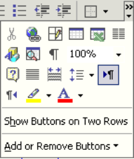
You can display the Standard and the Formatting toolbars on one row, or on two rows.
Toolbar Options arrow
To display these toolbars on 2 rows (recommended):
- Click on the Toolbar Options arrow.
- Click on Show Buttons on Two Rows.
Alternatively you can do this from the Customize dialog box as follows:
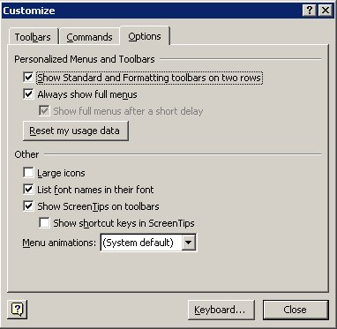
- From the Tools menu, select Customize, and then click the Options tab.
or
- From the View menu, point to Toolbars, then Customize, and then click the Options tab.
or
- Right-click on any menu or toolbar and select Customize from the shortcut menu then click the Options tab.
- Ensure the Show Standard and Formatting toolbars on two rows check box is ticked
- Click Close.
Helpful hint:
The Show Standard and Formatting toolbars on two rows check box affects only Microsoft Word. The check box is not available if either the Standard or Formatting toolbar is hidden, or if both toolbars are floating.
When you begin typing a new document, the text appears in the font (typeface) and font size (measured in points) that are predefined for Word. To achieve a different look, you can choose other formats for Word to use. Formatting encompasses:
Font | Times | Courier | Arial
Font style | Regular | Bold | italic
Size | 12 | 24 | 72
Case | UPPERCASE | lowercase | Title Case
Colour | Red | Green | Blue
Highlight | Red | Green | Blue
You can apply formats by clicking a button on the Formatting toolbar, by pressing shortcut keys, or by clicking Font on the Format menu.

Formatting toolbar
The most common formatting options can be found on the Formatting toolbar. We will concentrate on applying formats using the Formatting toolbar in this section.
Font
Font Size
Bold
Italic
Underline
Font Color

Formatting Text

Character Formatting

Changing the appearance of text
Before you can apply formatting to existing text you must first select the text. (For selecting techniques see page Error: Reference source not found).

Emboldening, italicising and underlining text
Bold
Italic
Underline
- Select the text to be formatted.
- Click on the required formatting button or combination of buttons on the Formatting toolbar (i.e. bold, italic and underline), or press Ctrl+B, Ctrl+I or Ctrl+U.
- Click anywhere in the document to deselect the text. The selected format is applied to the selected text.

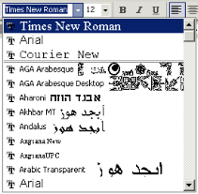
Changing the font type
- Select the text to be formatted.
- In the Font list, select the required font e.g. Arial.
- Click anywhere in the document to deselect the text. The selected format is applied to the selected text.

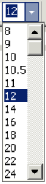
Changing font size
- Select the text to be formatted.
- In the Font Size list, select the required point size e.g. 10.
- Click anywhere in the document to deselect the text. The selected format is applied to the selected text.

Revealing the formatting of your text
- Go to the task pane, click on the Other Task Panes arrow and choose Reveal formatting.
- The formatting for the selected text will be displayed in the task pane.

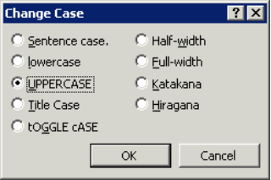
Changing case
- Select the text to be formatted.
- On the Format menu, click Change Case. The Change Case dialog box will appear.
- Select as appropriate and click OK.

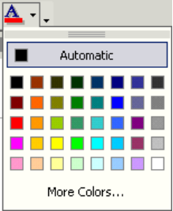
Changing the font colour
- Select the text to be formatted.
- In the Font Color box, select the required colour from the palette.
- Click anywhere in the document to deselect the text. The selected format is applied to the selected text.

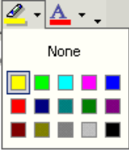
Highlighting text
- Select the text to be formatted.
- In the Highlight box select the required colour from the palette.
- Click anywhere in the document to deselect the text. The selected format is applied to the selected text.
This text has been highlighted.
To remove highlighting:
- Select the text that has the highlighting.
- Click the drop-down arrow on the right of the Highlight button.
- Choose None to remove the highlighting from the selected text.

Keyboard shortcuts for character formatting
It is sometimes quicker to use key combinations to apply formatting to text within a document. The table below lists the shortcut keys that you can use to do this:
To | Keystroke
Increase the font size | Ctrl+Shift>
Decrease the font size | Ctrl+Shift<
Increase the font size by 1 point | Ctrl+]
Decrease the font size by 1 point | Ctrl+[
Display the Format |Font dialog box | Ctrl+D
Format letters as all capitals | Ctrl+Shift+A
Apply bold formatting | Ctrl+B
Apply an underline | Ctrl+U
Underline words but not spaces | Ctrl+Shift+W
Double-underline text | Ctrl+Shift+D
Apply hidden text formatting | Ctrl+Shift+H
Apply italic formatting | Ctrl+I
Format letters as small capitals | Ctrl+Shift+K
Apply subscript formatting (automatic spacing) | Ctrl+=
Apply superscript formatting (automatic spacing) | Ctrl+Shift++
Remove manual character formatting | Ctrl+Spacebar

Paragraphs Formatting
Some formatting options within Word apply to paragraphs, for example, alignment, line spacing, borders and shading, indentation and tabs. A paragraph may consist of a number of lines of text, a single word or no text at all. A paragraph is created every time the Enter ↵ key is pressed. The end of each paragraph is defined by a paragraph mark: ¶.
Helpful hint:
Border and shading options can be applied to any selected text within a paragraph.
To display paragraph marks, click on the Show/Hide button on the Formatting toolbar. You may have to add this button to the toolbar using the Add or Remove button (off the Toolbar Options arrow).
Paragraph formats can be applied in a number of different ways; from the Format menu, the Formatting toolbar, the ruler or shortcut keys, and the Reveal Formatting task pane.
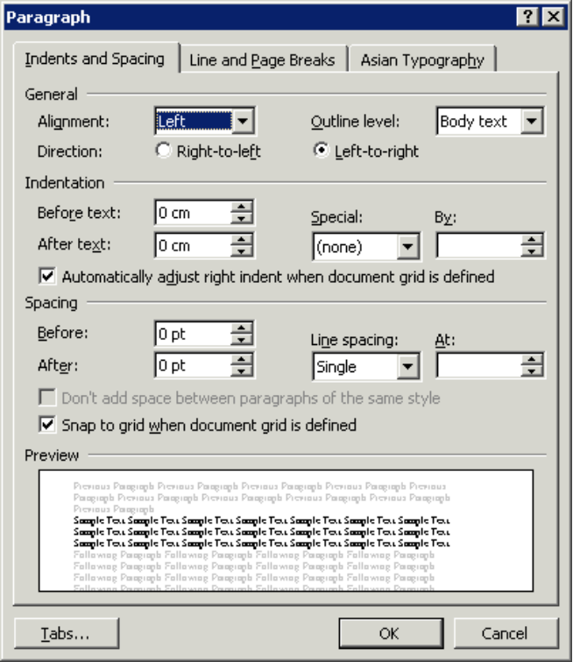
To make several different types of changes to the paragraph(s) at the same time, you can click the Paragraph option on the Format menu. You can set indentation, alignment, line spacing and tabs in the Paragraph dialog box as shown below.
You can set indentation from the left-hand margin here.
You can set indentation from the right-hand margin here.
You can set line spacing here.
Alignment can be specified here.
You can set tabs here.
First line and hanging indentation can be set here.
Full details are given for this in the Getting more from Word course. This course aims to give you an introduction to paragraph formatting using the Toolbar buttons.

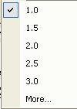
Changing line spacing
- Select the required paragraph(s).
- Click on the arrow on the Line Spacing button on the Toolbar.
- Select the required line spacing option. (Clicking More will open the Paragraph dialog box.)
- Your chosen line spacing will have been applied to your selected paragraphs.

Aligning text
- Select the required paragraph.
- Click the appropriate button on the toolbar to align your text.
Click this button to left-align paragraphs. Left alignment ensures that the left edge of each line in the paragraph begins at the same place. Because of the word-wrapping, the right-hand edge of the paragraph won’t line up exactly; this is sometimes called a “ragged” edge. Left alignment is the default alignment for new Word documents.
Click this button to centre paragraphs. This will make each line of the paragraph position its centre point in the middle of the page. Both the left and right edges of the paragraph will be ragged.
Click this button to right-align paragraphs. Right alignment ensures that the right edge of each line in the paragraph begins at the same place – the left edge will be ragged.
Click this button to justify paragraphs. This ensures that both the left-hand and right-hand edges of the lines in the paragraph begin and end at the same position, eliminating any ragged edges.
Alternatively, you can use your keyboard to align text by pressing Ctrl +L to left-align, Ctrl+R to right-align, Ctrl+E to centre or Ctrl+J to justify.

Indents
You can use indentation to emphasise a paragraph. Indents squeeze the paragraph text between the left and/or right margins, thus reducing line length. The paragraph text is in effect framed with white space.
Word allows you to create four main types of indentation: left indents, right indents, hanging indents and first line indents.
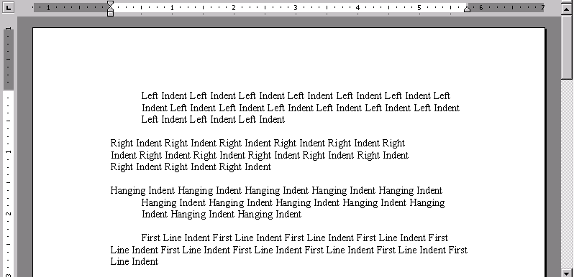
- A left indent moves the entire paragraph from the left-hand margin.
- A right indent moves the entire paragraph from the right-hand margin.
- A hanging indent means that the entire paragraph except the first line is indented from the left-hand margin.
- A first line indent means that only the first line of the paragraph is indented, while the rest of the lines rest against the left-hand margin.
To indent from the left:
- Click the cursor inside the paragraph whose alignment you want to change or, if you are aligning several paragraphs, highlight them.
- Click the increase indent button to indent the selected paragraphs by 25mm (½ inch) from the left. You can click this button again to increase by a further 25mm (½ inch) and so on.
- If you need to take the paragraph back by ½ inch, click the decrease indent button.
Other methods of indenting paragraphs, including using the Paragraph dialog box, and using the ruler, are covered on the Getting more from Word course.

Formatting as you work
Formatting can also be applied as you work.
For example, to type bold text, first click the Bold button on the Formatting toolbar: The Bold button changes to a lighter shade of grey. This means that bold is on.
Type your text, and then click the Bold button again on the Formatting toolbar to return to regular text. The Bold button changes back to dark grey, which means bold is off.
Any combination of formats can be applied in this manner. For example, clicking on the Italic button switches on Italics, etc.
Helpful hint:
You can apply several formatting options to a selection of text. You do not need to deselect text after each formatting option has been applied. The text will change within the selection to show the formatting as it is applied.

Keyboard shortcuts for paragraph formatting
The table below lists shortcut keys for paragraph formatting:
Single-space lines | Ctrl+1
Double-space lines | Ctrl+2
Set 1.5-line spacing | Ctrl+5
Add or remove one line space preceding a paragraph | Ctrl+0
Centre a paragraph | Ctrl+E
Justify a paragraph | Ctrl+J
Left align a paragraph | Ctrl+L
Right align a paragraph | Ctrl+R
Indent a paragraph from the left | Ctrl+M
Remove a paragraph indent from the left | Ctrl+Shift+M
Create a hanging indent | Ctrl+T
Reduce a hanging indent | Ctrl+Shift+T
Remove paragraph formatting | Ctrl+Q

Additional formatting concepts

Other font formats
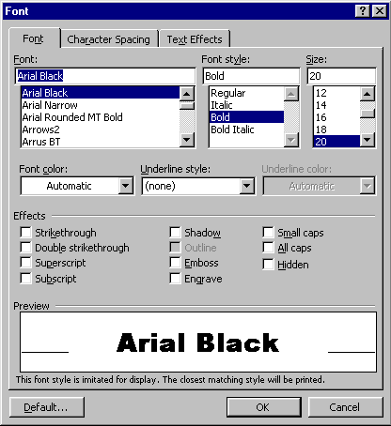The Formatting toolbar contains the most commonly applied formats; however there are more options available in the Font dialog box.
To access the Font dialog box:
- Select the text to format.
- From the Format menu select Font. The following dialog box will appear:
The dialog box contains three tabs – Font, Character Spacing and Text Effects.

Font tab
Most of the options on the Font tab are the same as those on the formatting toolbar. However, the Underline options include some extra underline styles. The dialog box also has more effects than using the formatting toolbar.

Underline styles
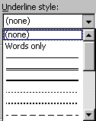To change the style of any underlining that you apply:
- Select the text to format then, from the Font dialog box, click the Font tab.
- Click the drop-down arrow to the right of the Underline style box – a selection of different underline options will appear.
- Choose your preferred option by clicking on it. The Preview window at the bottom of the dialog box displays a preview of how your text will look if you choose to keep the applied formats.
- Click the OK button to keep the format. Clicking Cancel will abandon any choices you have made and close the dialog box.

Effects
Most of the effects change the appearance of the characters. Superscript and Subscript allow you to raise and lower characters (e.g. 10m² or H₂O).
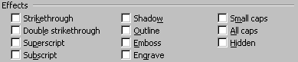Some effects have more useful functions – for example Hidden renders text on-screen and in the printed document invisible, particularly useful if you want to hide references to the source of a document or picture so they don’t get printed. Hidden text will show on-screen if the Show/Hide button is clicked on.
To apply effects:
- Select the text to format.
- Access the Font dialog box and click the Font tab.
- Check the boxes by clicking in them with the mouse next to the relevant options to switch them on. The Preview window will show you what each one will look like.
- Uncheck the boxes to switch an effect off.
Helpful hint:
Some effects can be switched on in combination, others are mutually exclusive (for example you cannot have both Small caps and All caps applied as switching one on will automatically disable the other.

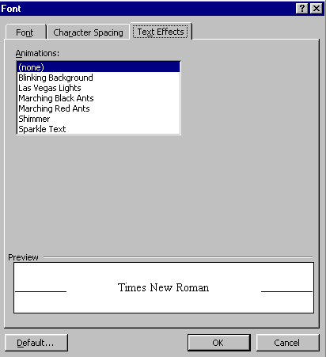Text Effects tab
The Text Effects tab contains a list of animation effects that can be attached to text in a document. These effects will show up on-screen but do not appear in print outs (the text still prints but the effects do not).
To apply animation effects:
- Select the text to format.
- From the Font dialog box, click the Text Effects tab.
- Choose the effect you want to apply to the selected text. The Preview window will show you what the effect looks like should you choose to apply it. Only one effect at a time can be chosen.
- Click the OK button to keep the change or the Cancel button to abandon it.

Format painter
Once you’ve formatted text to look the way you want, use the Format Painter button on the Standard toolbar to copy the formatting to selected text elsewhere in the document. You may need to add the Format Painter button to your toolbar, by using the add/remove buttons (from the Toolbar Options arrow).
- Click anywhere in the formatted text.
- Click once on the Format Painter button: Notice the mouse pointer changes shape.
- Now select the unformatted text. The text will adopt the new format.
Helpful hint:
By double-clicking on the Format Painter button you can copy the format to multiple locations. To finish ‘painting’ press Esc or click again on the Format Painter button.

Word Styles

Types of Styles

Character and Paragraph

Default and User Defined

Applying Styles

Modifying Styles

